How to allow azure sevices to use database

1. Go to database
2. Go to set server firewall

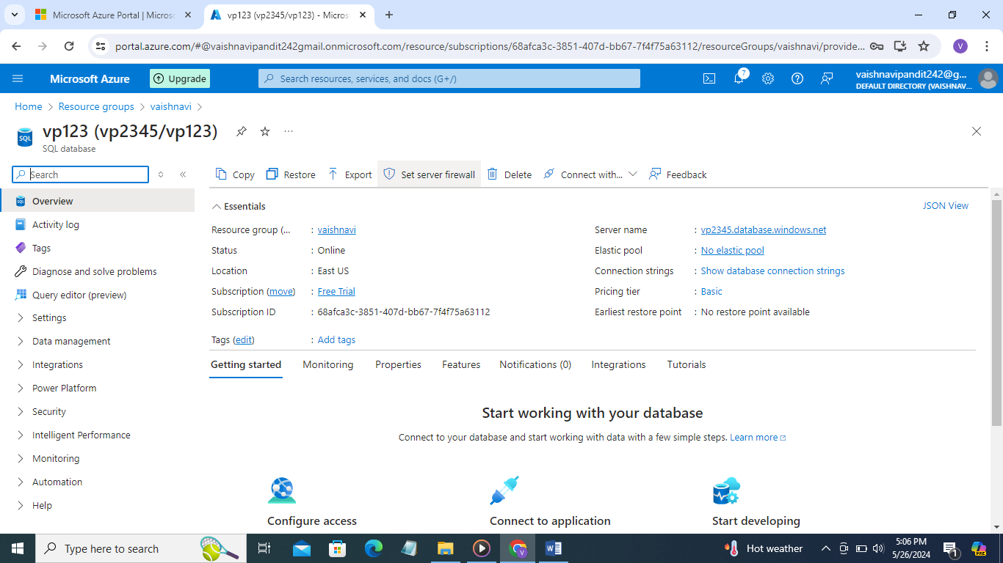

1. Go to selected network

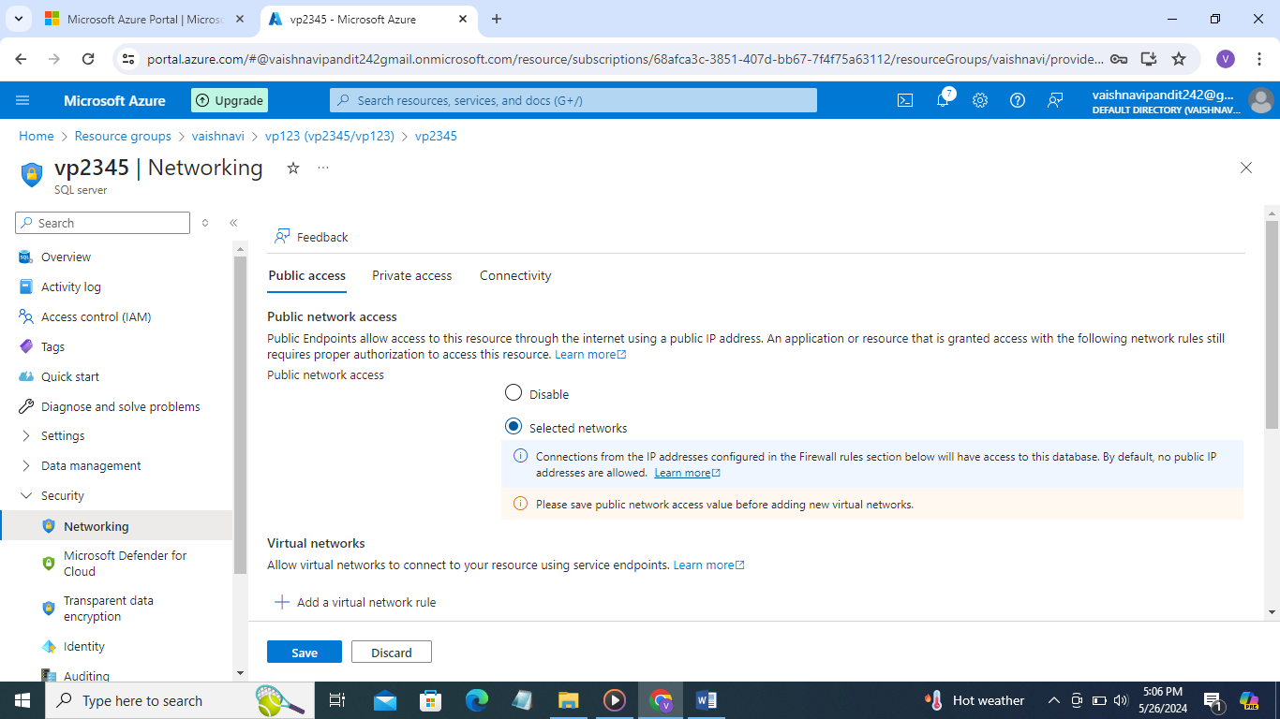

1. Now go to the firewall rules
2. And select first one

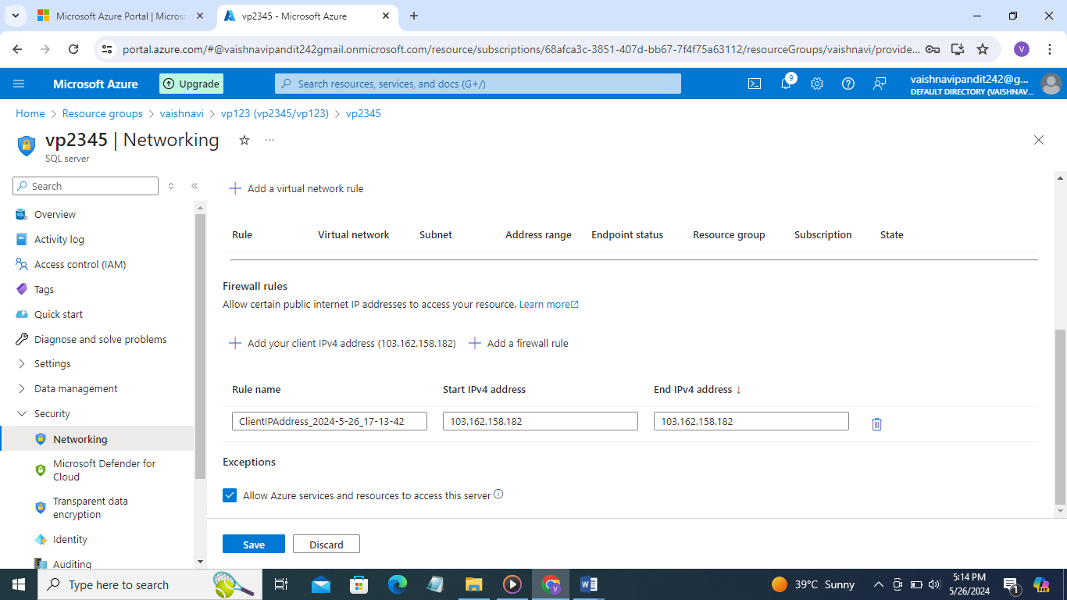

1. Allow azure services and resouces to access this server

